**Python – The New Boston**

URL : <https://www.youtube.com/watch?v=HBxCHonP6Ro&list=PL6gx4Cwl9DGAcbMi1sH6oAMk4JHw91mC_>

1. **Tutorial 1 : Installing Python**

<https://www.python.org/>

Python can be used to make:

* Desktop apps, computer games, web apps, web crawlers etc.

Install the latest stable version : 3.x.x

Feel free to use IDLE(Python shell) for testing small programs.

1. **Tutorial 2 : Numbers**

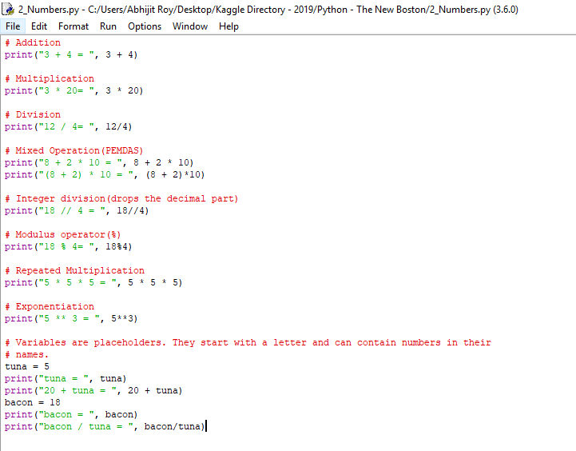

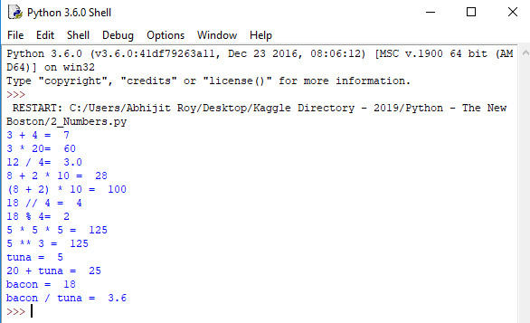

1. **Tutorial 3 : Strings**

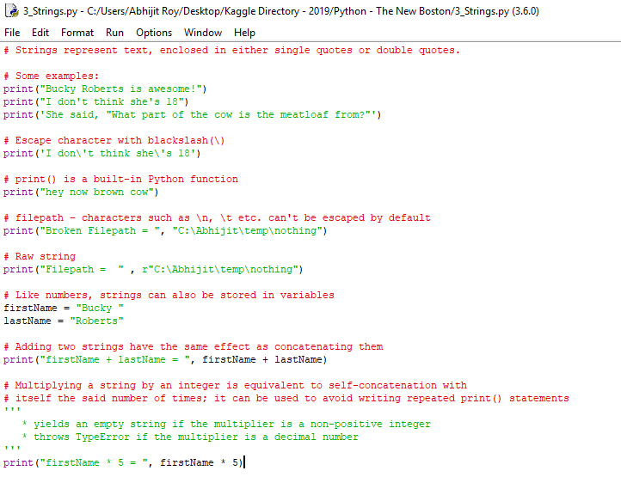

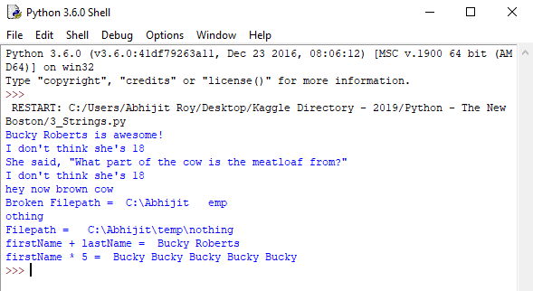

1. **Tutorial 4 : Slicing Up Strings**

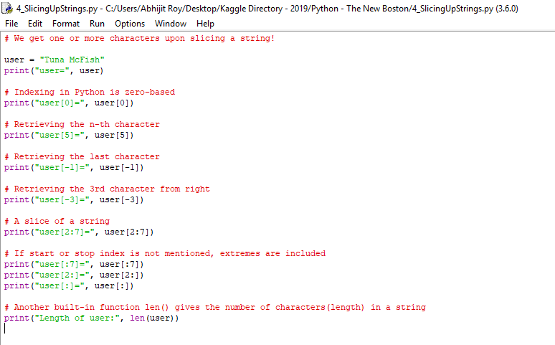

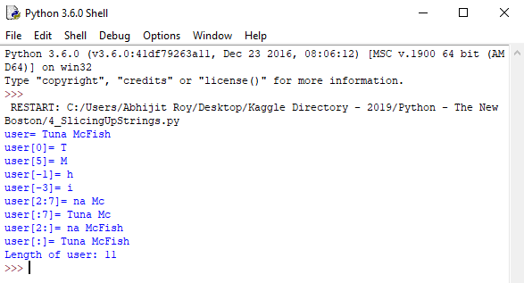

1. **Tutorial 5 : Lists**

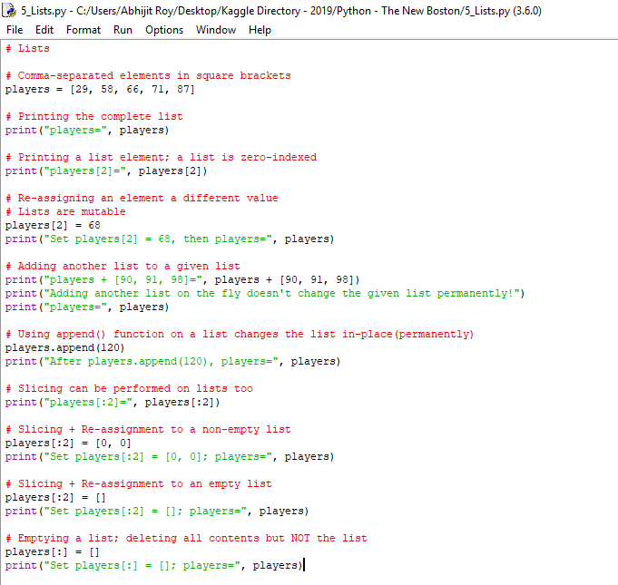

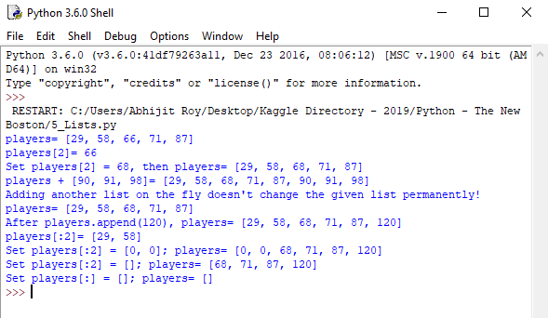

1. **Tutorial 6 : Installing PyCharm**

IDLE is ideal for testing small programs, but we need a more advanced IDE for working on projects having multiple files.

Get PyCharm Community Edition from : <https://www.jetbrains.com/pycharm/download/#section=windows>

1. **Tutorial 7 : if elif else**

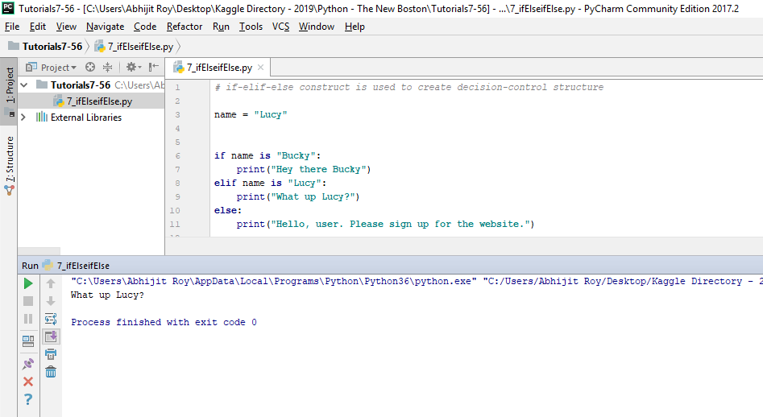

1. **Tutorial 8 : for**

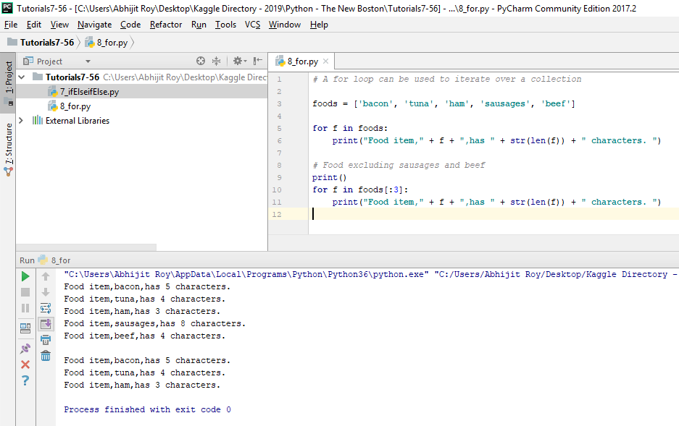

1. **Tutorial 9 : Range and While**

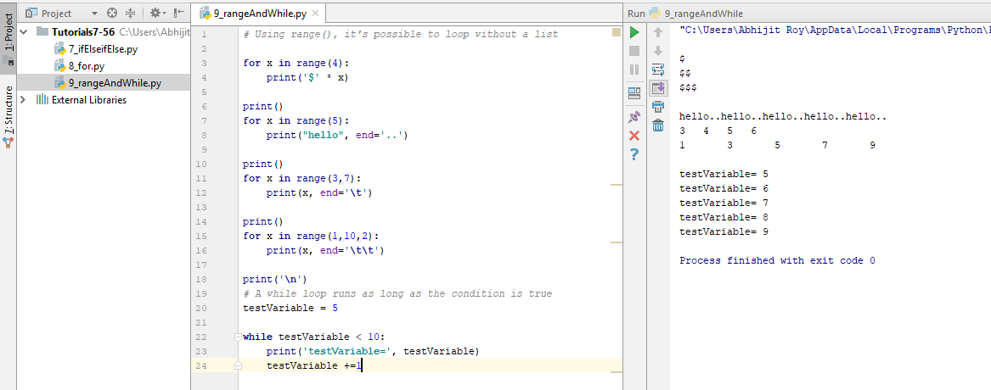

1. **Tutorial 10 : Comments and Break**

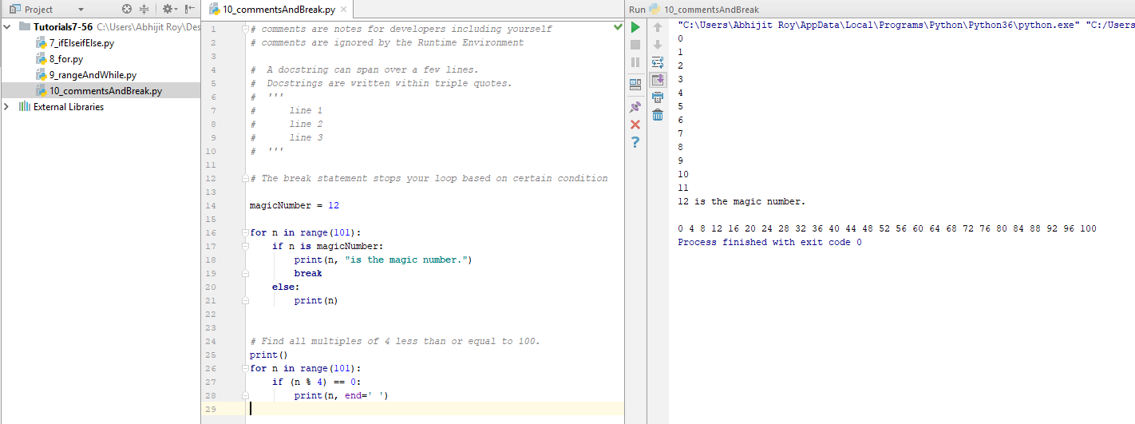

1. **Tutorial 11 : Continue**

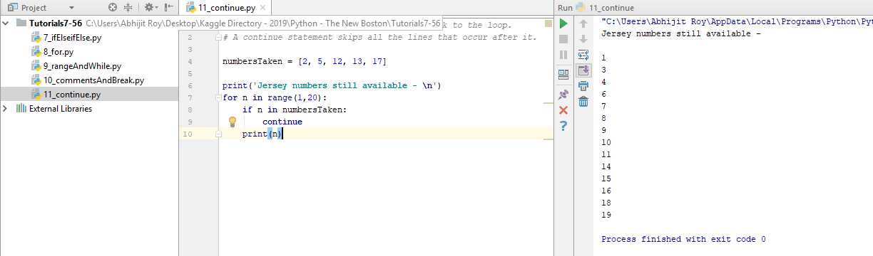

1. **Tutorial 12: Functions**

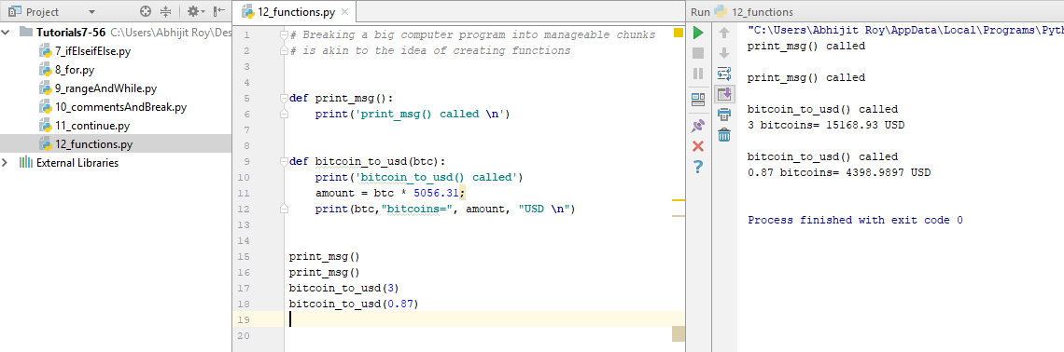

1. **Tutorial 13 : Return Values**

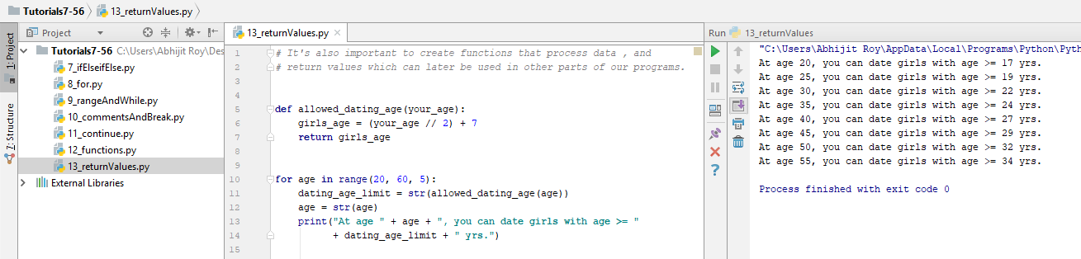

1. **Tutorial 14 : Default Values for Arguments**

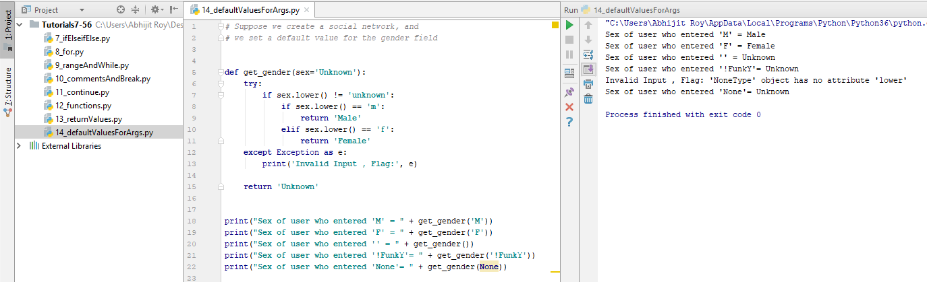

1. **Tutorial 15 : Variable Scope**

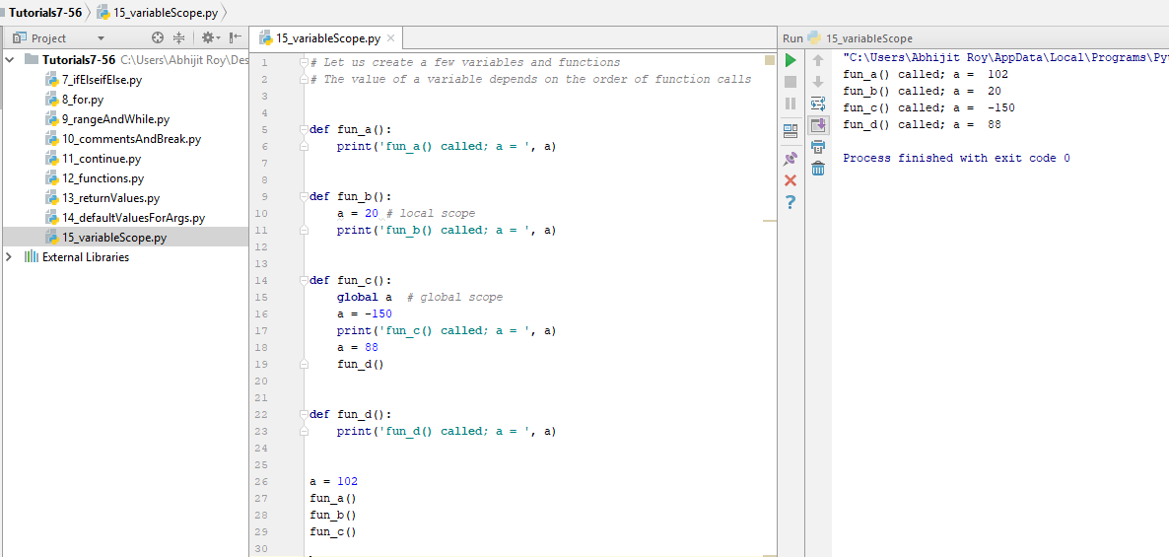

1. **Tutorial 16 : Keyword Arguments**

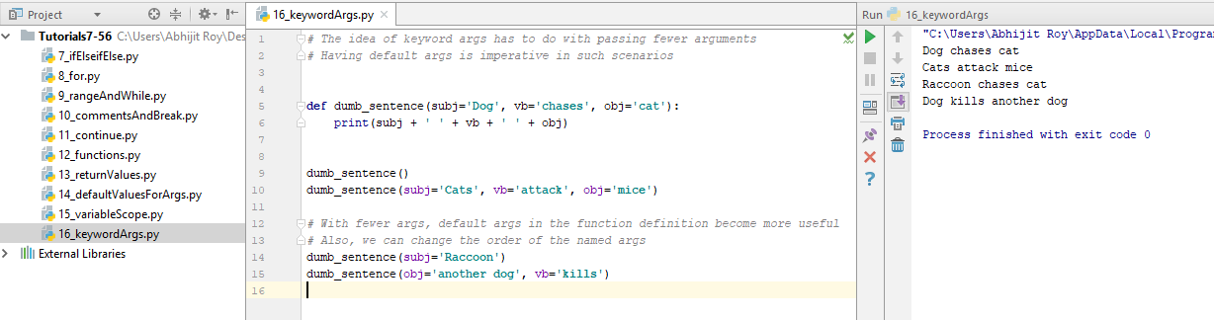

1. **Tutorial 17 : Flexible Number of Arguments**

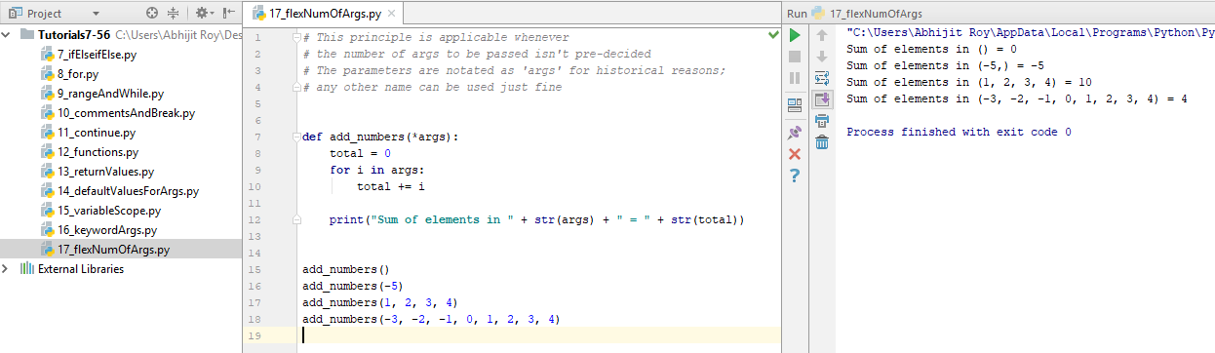

1. **Tutorial 18 : Unpacking Arguments**

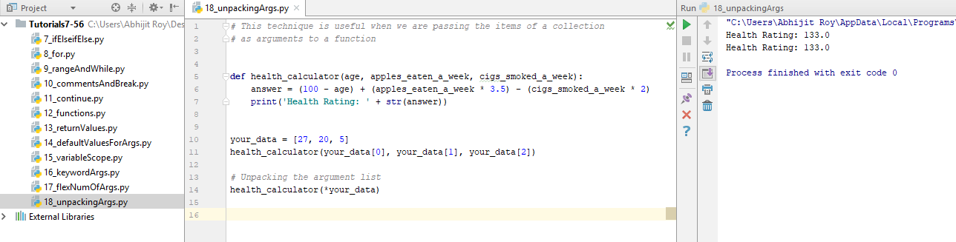

1. **Tutorial 19 : Sets**

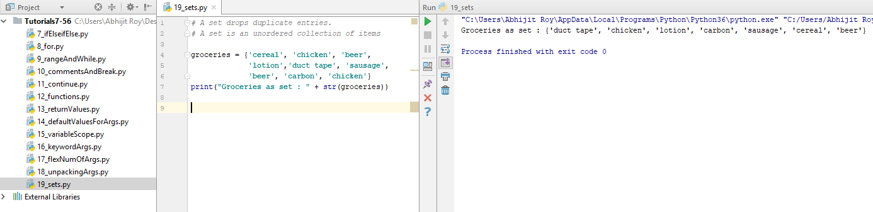

1. **Tutorial 20 : Dictionary**

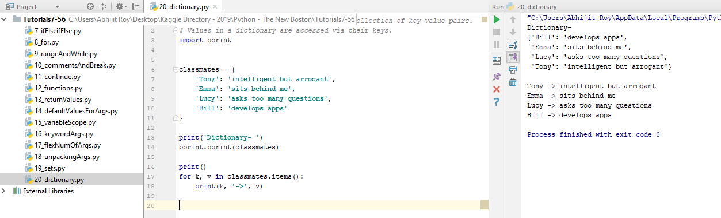

1. **Tutorial 21 : Modules**

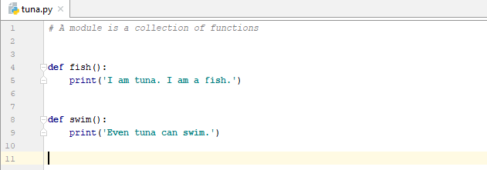

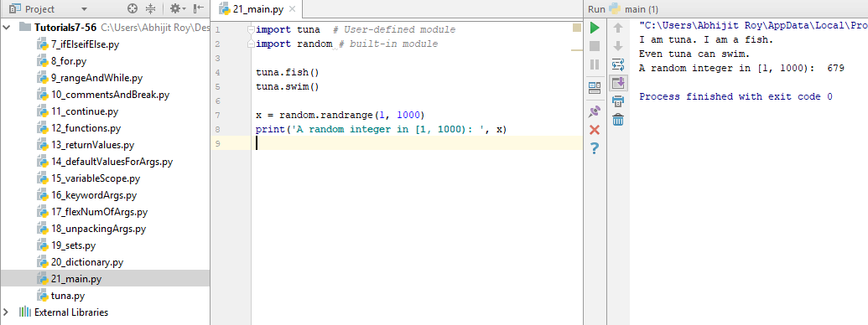

1. **Tutorial 22 : Download an Image from the Web**

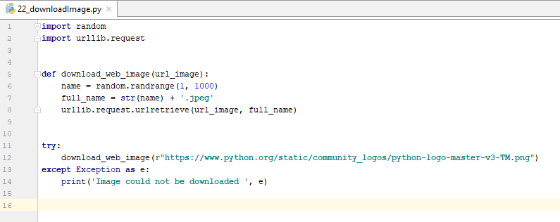

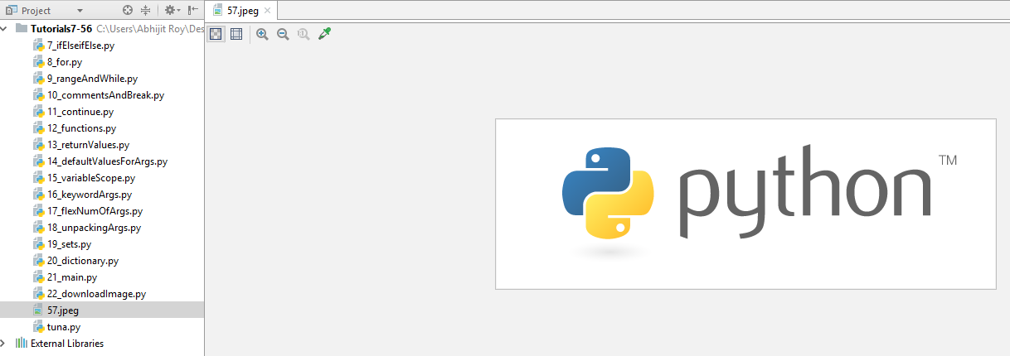

1. **Tutorial 23 : How to Read and Write Files**

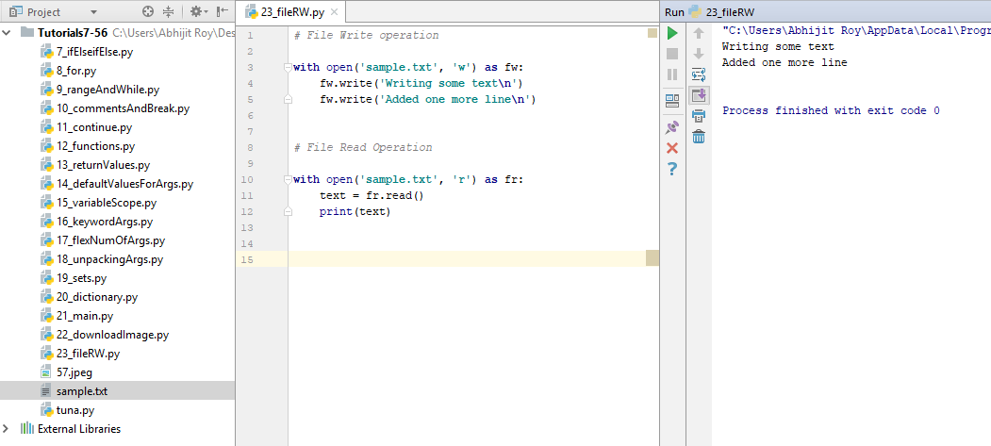

1. **Tutorial 24 : Downloading Files from the Web**

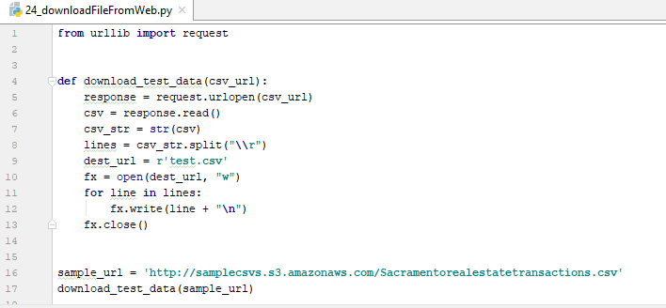

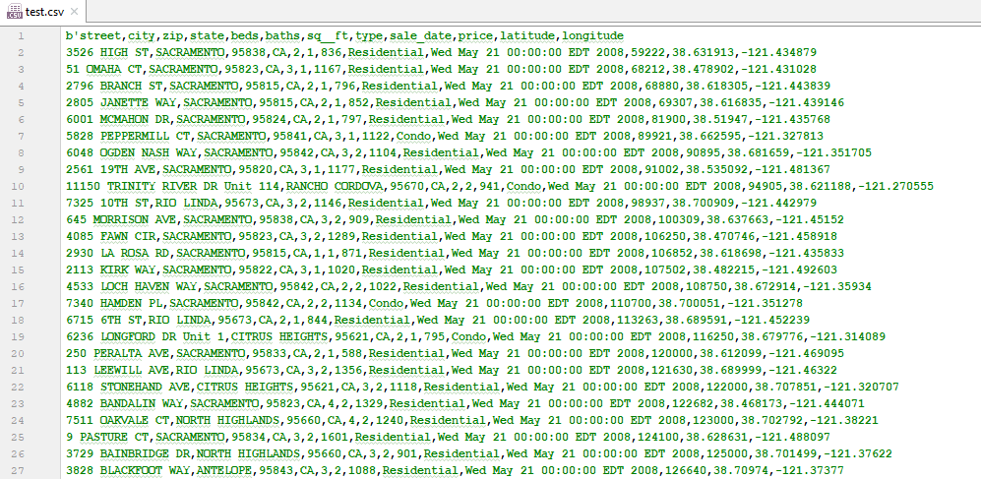

1. **Tutorial 25 : How to Build a Web Crawler(1/3, 2/3, 3/3)**

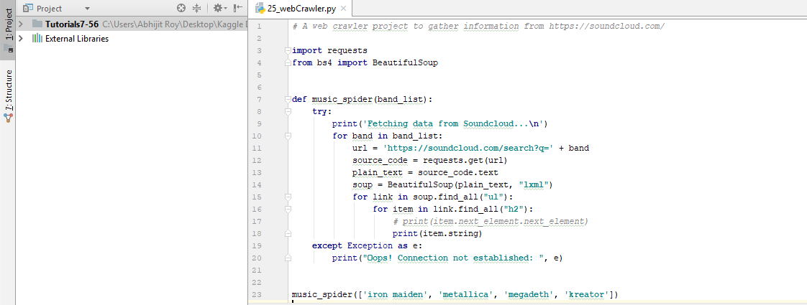

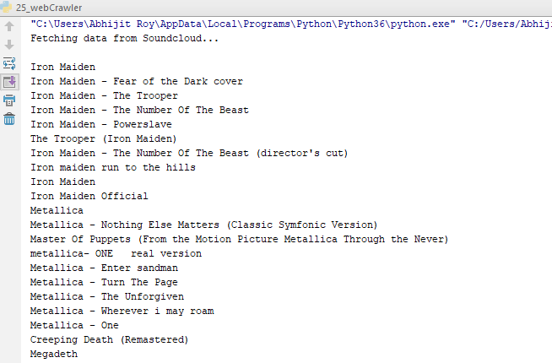

1. Tutorial 26 : - do –
2. Tutorial 27 : - do –
3. **Tutorial 28 : You are the only Exception**

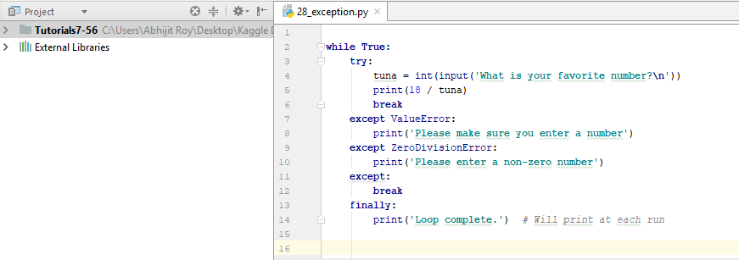

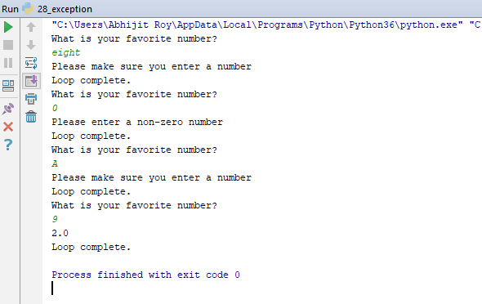

1. **Tutorial 29 : Classes and Objects**

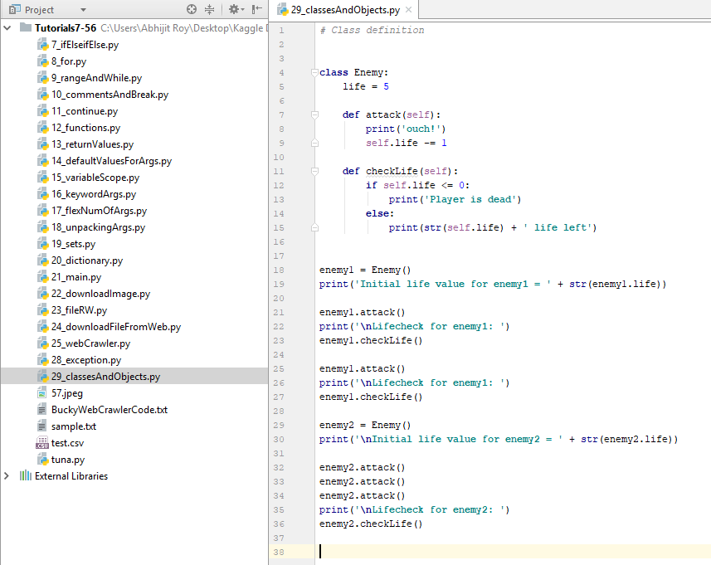

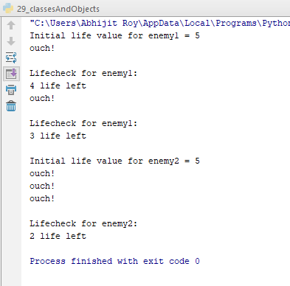

1. **Tutorial 30 : init**

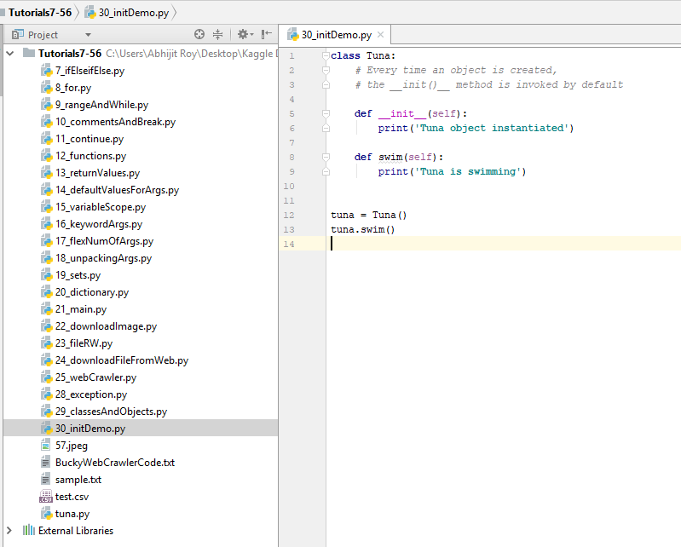

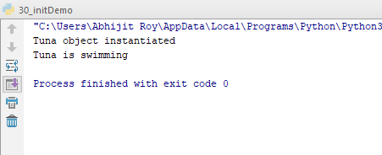

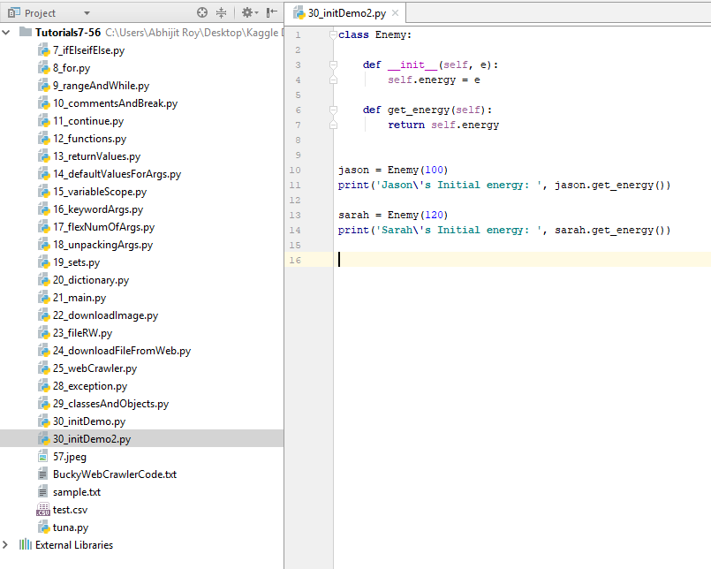

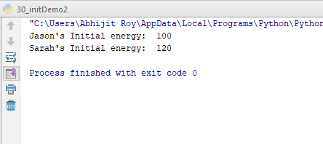

1. **Tutorial 31 : Class vs Instance Variables**

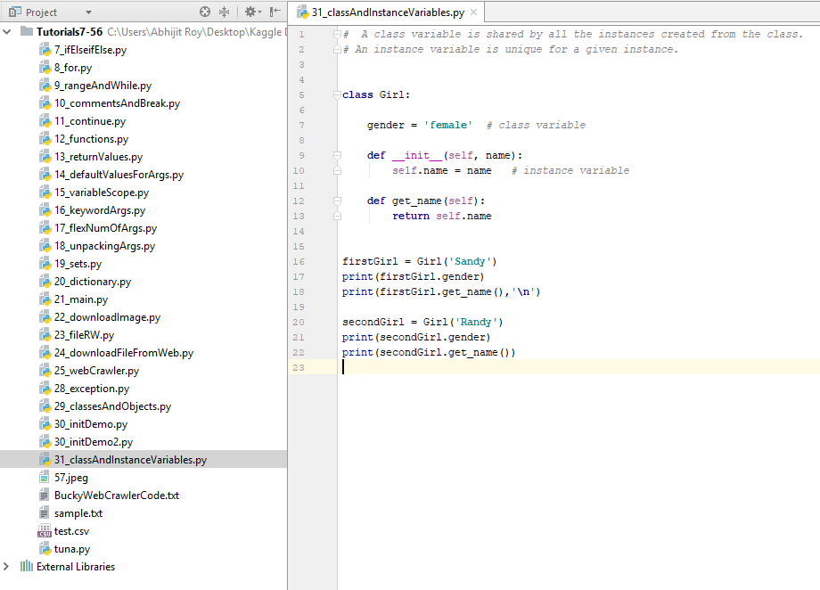

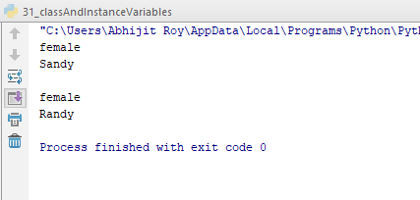

1. **Tutorial 32 : Inheritance**

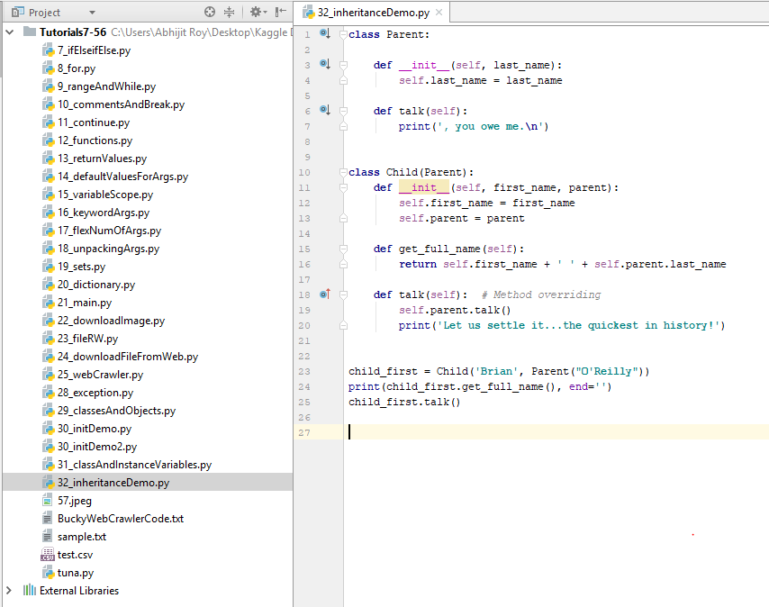

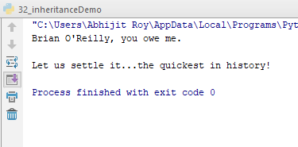

1. **Tutorial 33 : Multiple Inheritance**

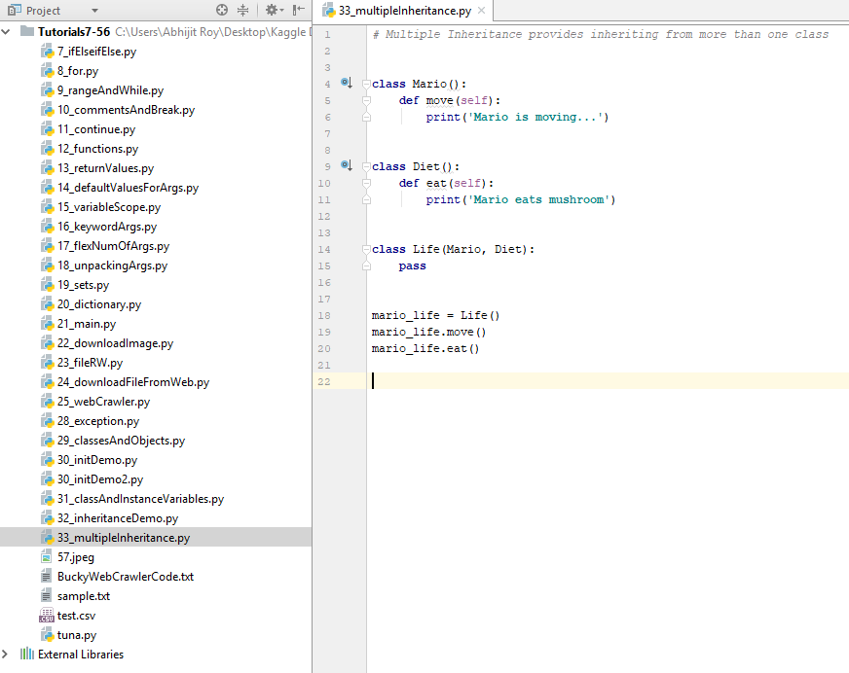

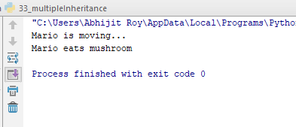

1. **Tutorial 34 : Threading**

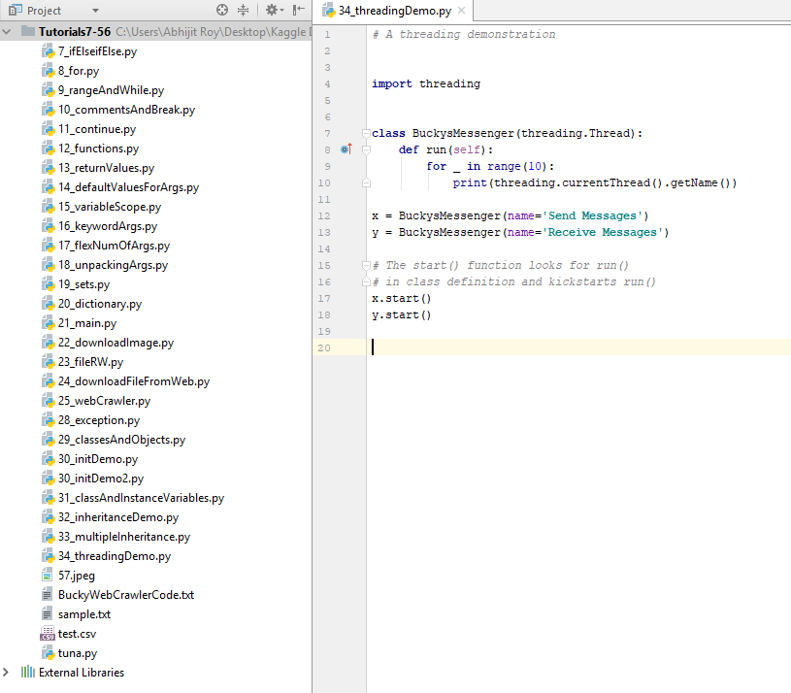

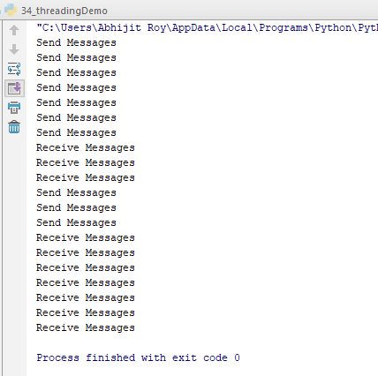

1. **Tutorial 35 : Word Frequency Counter(1 / 3, 2 / 3, 3 / 3)**

Please refer to the file path :

C:\Users\Abhijit Roy\Desktop\Kaggle Directory - 2019\Python - The New Boston\Tutorials7-56

The file name is:

35_wordFreqCounter.py

1. **Tutorial 36 : - do –**
2. **Tutorial 37 : - do –**
3. **Tutorial 38 : Unpack List or Tuple**

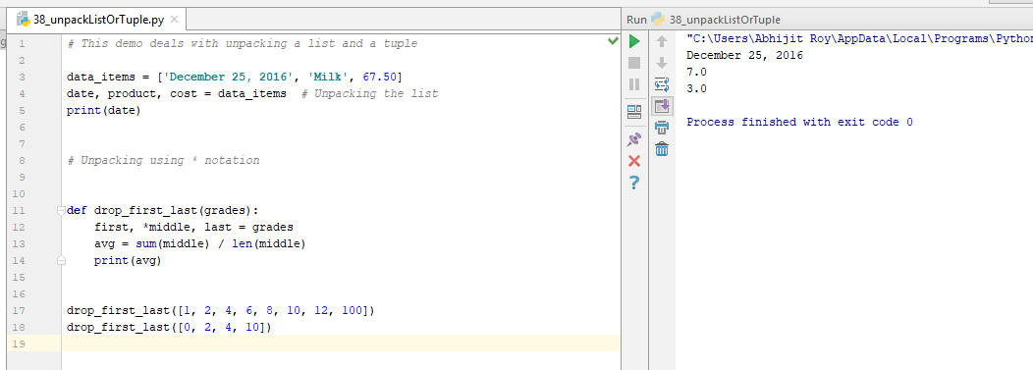

1. **Tutorial 39 : zip**

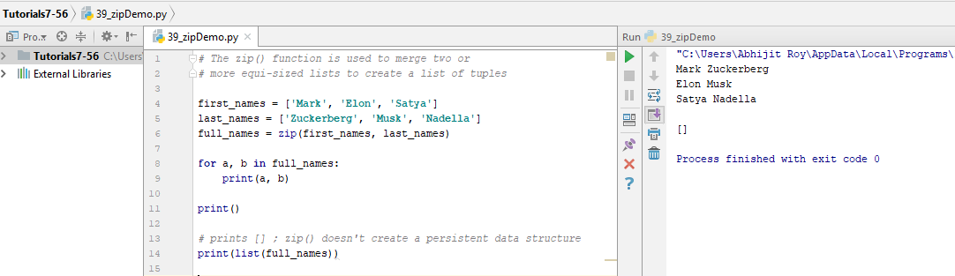

1. **Tutorial 40 : lambda**

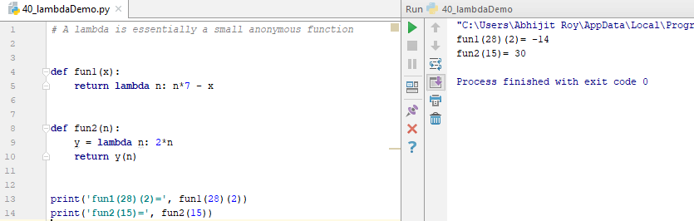

1. **Tutorial 41 : Min, Max, and Sorting Dictionaries**

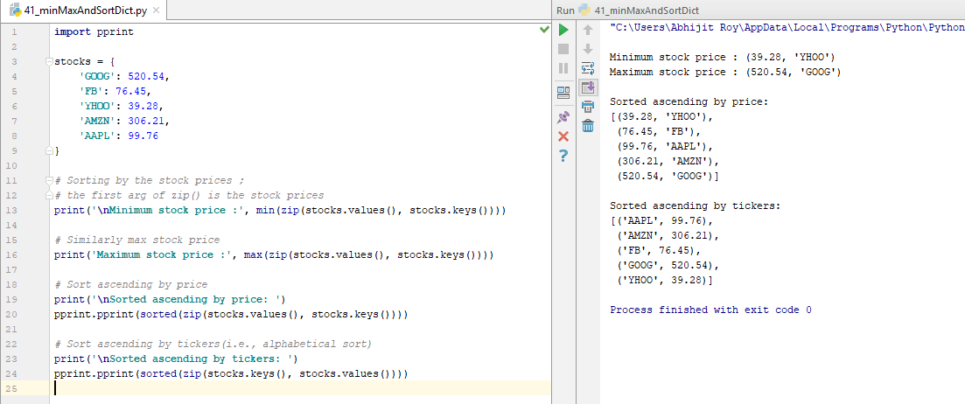

1. **Tutorial 42 : pillow**
2. **Tutorial 43 : Cropping Images**
3. **Tutorial 44 : Combine Images Together**
4. **Tutorial 45 : Getting Individual Channels**
5. **Tutorial 46 : Awesome Merge Effect**
6. **Tutorial 47 : Basic Transformations**
7. **Tutorial 48 : Modes and Filters**

Refer to the file 42_pillowDemo.py

1. **Tutorial 49 : struct**

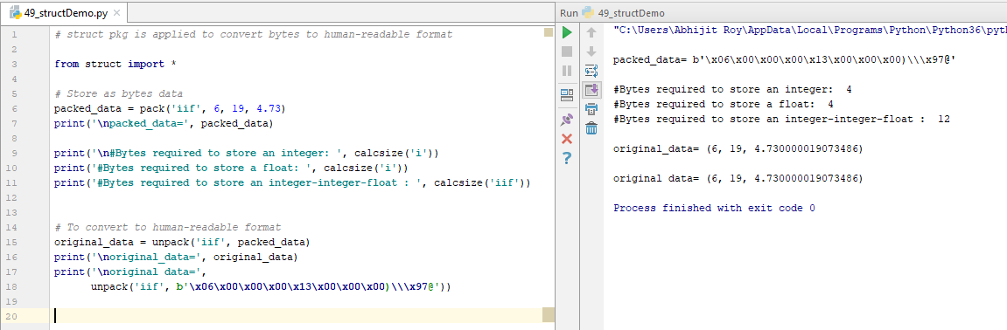

1. **Tutorial 50 : map**

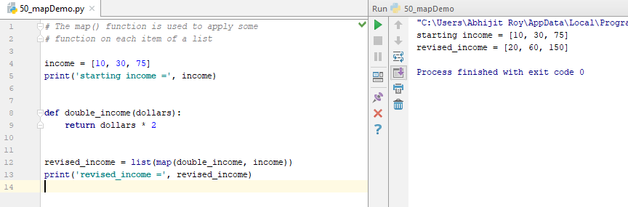

1. **Tutorial 51 : Bitwise Operators**

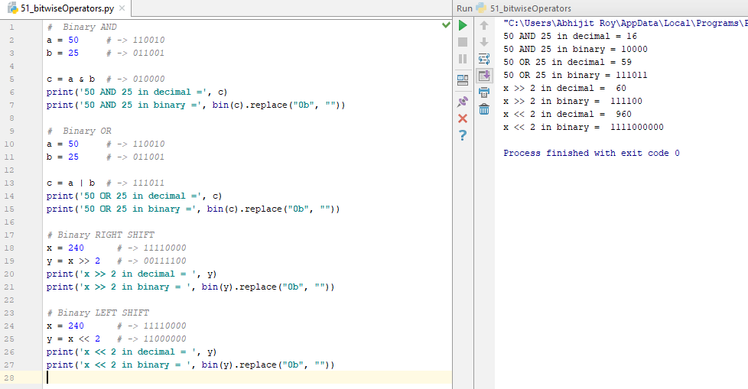

1. **Tutorial 52 : Finding Largest or Smallest Items**

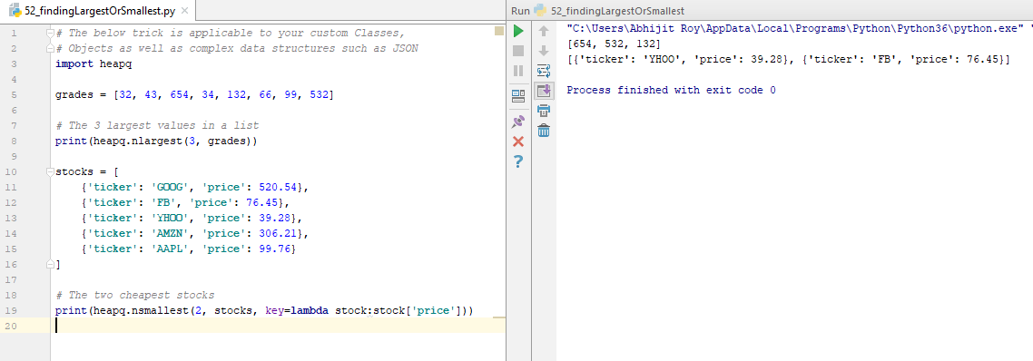

1. **Tutorial 53 : Dictionary Calculations**

It’s a simple recap of Tutorial 41,

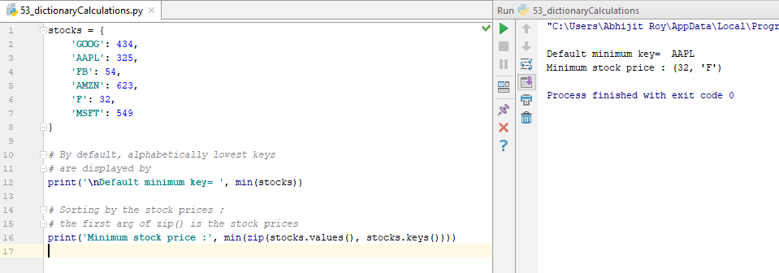

1. **Tutorial 54 : Finding Most Frequent Items**

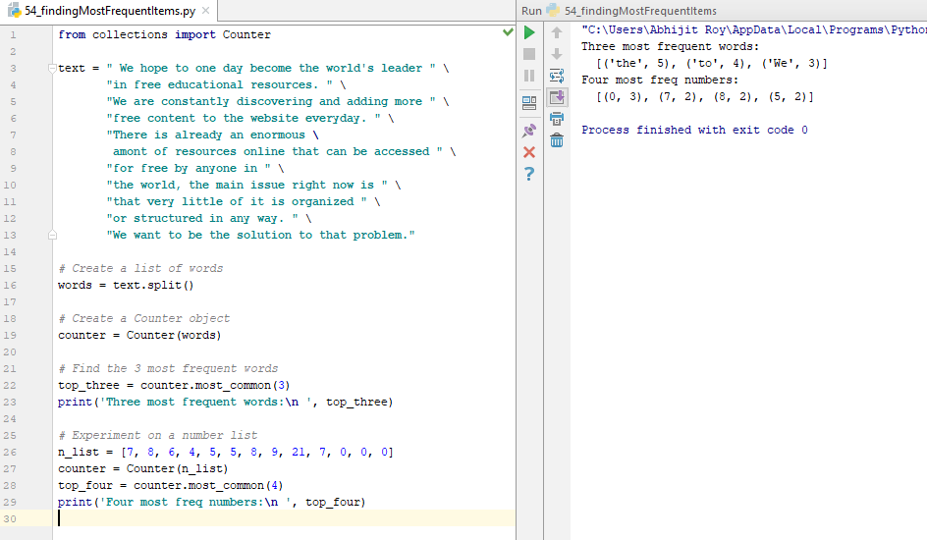

1. **Tutorial 55 : Dictionary Multiple Key Sort**

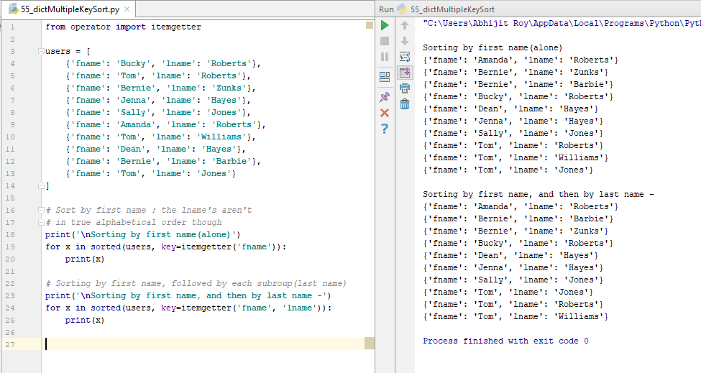

1. **Tutorial 56 : Sorting Custom Objects**

